**IS 6493**

**EXERCISE 0 - MARKDOWN**

**EXPECTED OUTPUT**

Task 1

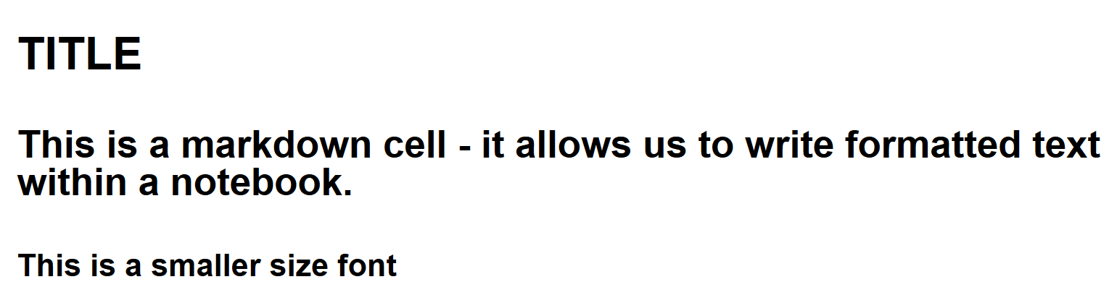

Task 2

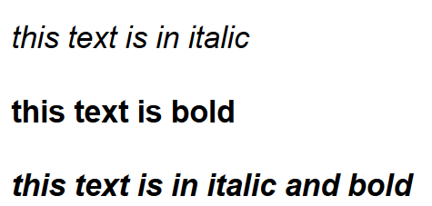

Task 3

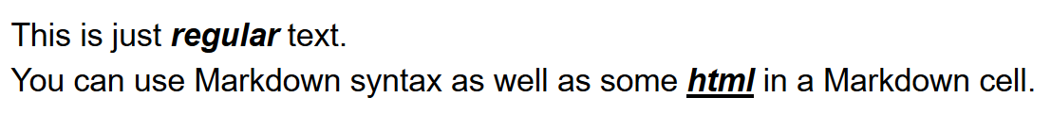

Task 4

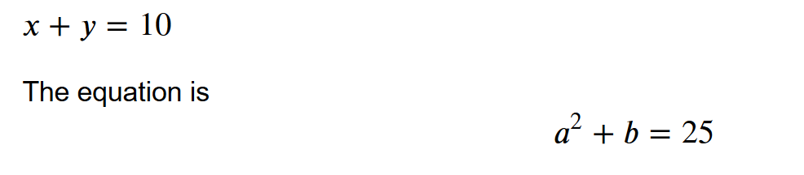

Task 5

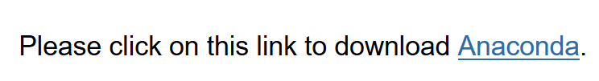

Task 6

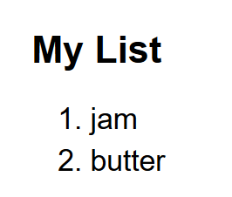

Task 7

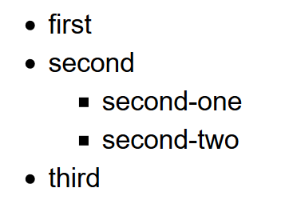

Task 8

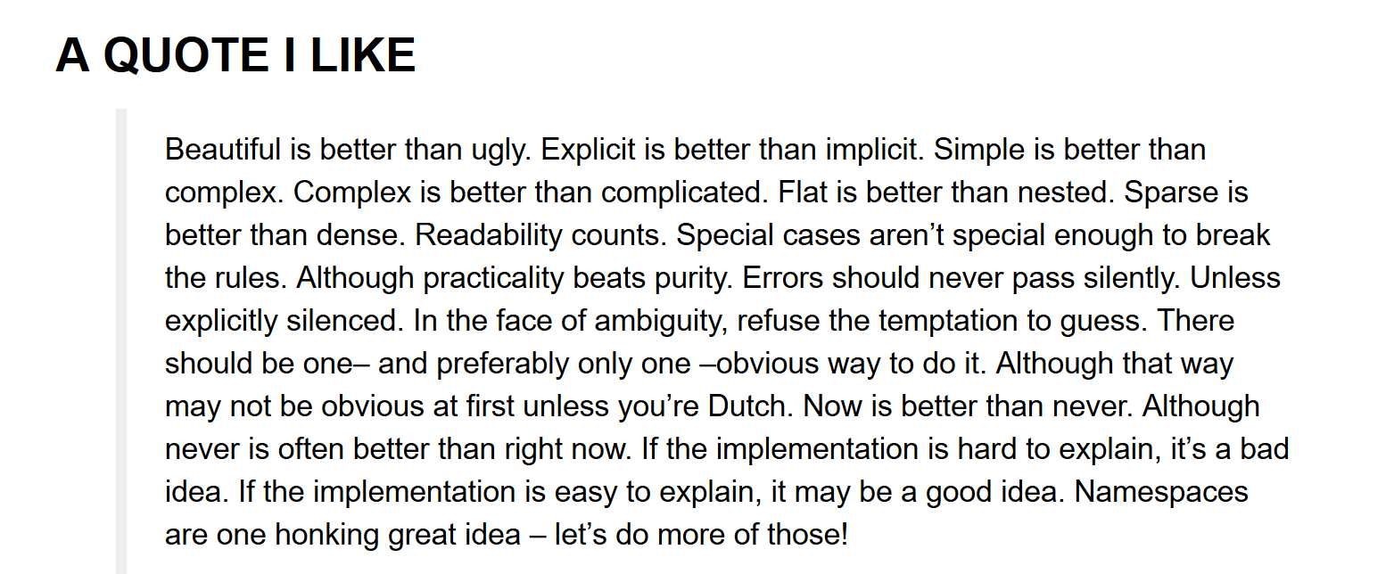

Task 9

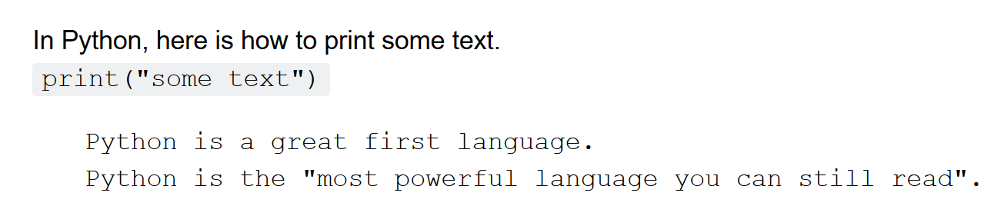

Task 10

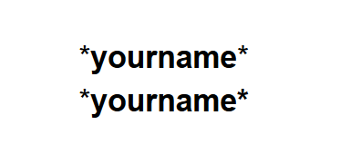

Task 11

